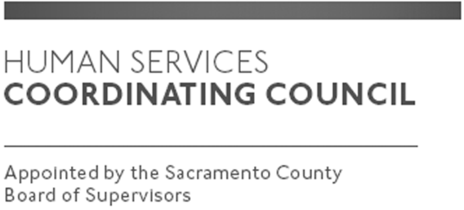

Sacramento County

Human Services Coordinating Council

Staffed by Cindy Marks, DHA

Meeting Agenda
March 12, 2020, Noon

Meeting Location
Dept. of Human Assistance
2700 Fulton Ave l Map
Sacramento, CA 95821
Conference Room 58

Facilitator: Ernie Brown – Chair

Meeting Invitees:
- HSCC Committee
- This meeting is open to the public

Topic | Presenter
Call to Order | Chair
Approval of February 13, 2020 Minutes | Chair
Sacramento County Budget- Presentation | DHA, DCFAS
Budget Ideas Moving Forward | Chair
Member Comments | Chair
Public Comments | Public
Announcements | TBD
Adjourn | Chair

