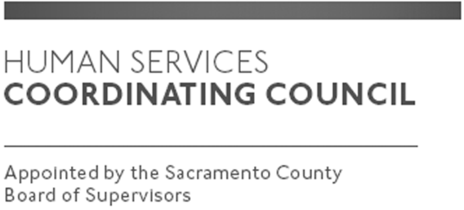

Sacramento County

Human Services Coordinating Council

Staffed by Cindy Marks, DHA

Meeting Agenda
January 9, 2020, Noon

Meeting Location
Dept. of Human Assistance
2700 Fulton Ave l Map
Sacramento, CA 95821
Conference Room 58

Facilitator: Kula Koenig-Main Facilitator
Raymond Kemp-Time Keeper
Ernie Brown – Chair/Other Facilitator Items

Meeting Invitees:
- HSCC Committee
- This meeting is open to the public
Topic | Presenter
Call to Order/ Potluck | Chair
Approval of December 12, 2019 Minutes | Chair
Don Nottoli- Presentation from 12:30 p.m.-1:00 p.m. | Don Nottoli
Retreat January 2020–General Information and Topic Ideas | HSCC Exec Team
POP Format Moving Forward-Purpose, Outcome, and Process | HSCC Exec Team
Member Comments | Chair
Public Comments | Public
Announcements | TBD
Adjourn | Chair

