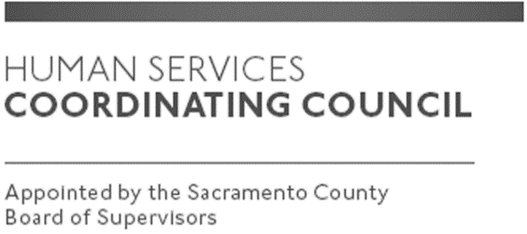

Sacramento County

Human Services Coordinating Council

Main Council Meeting

Human Services Coordinating Council

November Meeting Adjusted Schedule

Due to the Veterans Day holiday, which falls on Thursday, Nov. 11, 2021, the Human Services Coordinating Council main council meeting has been rescheduled for Thursday, Nov. 18, 2021, at 12:00 p.m. Please refer to the November 2021 HSCC meeting agenda for zoom meeting information. This meeting is open to the public.

