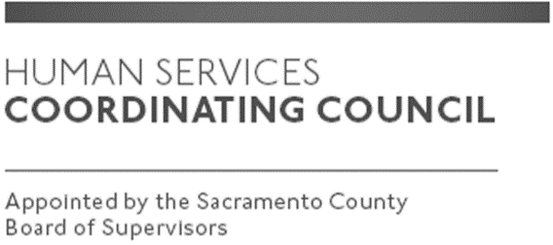

Sacramento County

Human Services Coordinating Council

Main Council Meeting

Staffed by Gloria Bedford, DCFAS

Meeting Agenda
March 11, 2020, Noon
Zoom Meeting
https://www.zoomgov.com/j/1619308600?from=addon
Meeting ID: 161 930 8600
Facilitator: Raymond Kemp – Chair
Meeting Invitees:
- HSCC Main Council Committee
- This meeting is open to the public.

Topic | Presenter
Call to Order | Chair
Approval of February 11, 2021 Minutes | Chair
Presentation: 211 Sacramento | Katherine Sorensen  Gabriel Kendall  211 Sacramento-Yolo
Discussion: Alternative 911 Response Plan Update | Jim Hunt  Health Services
Discussion: Recommendations from HSCC members re: Street Sheet | Members
Member Advisory Board Reports | Members
Public Comments | Public
Adjourn | Chair

