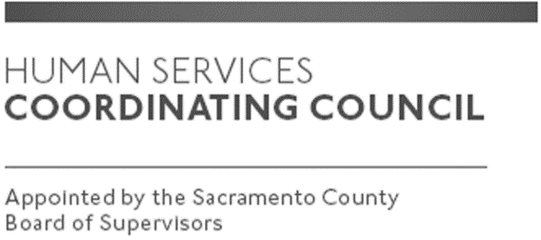

Sacramento County

Human Services Coordinating Council

Executive Committee Meeting

Staffed by Cindy Marks, DHA

Meeting Agenda
June 11, 2020, Noon

Meeting Location
Dept. of Human Assistance
Zoom via https://zoom.us/meeting/register/tJIrdeytpz8vGNTkGN2fK4baj9IKXWGllzyI
Facilitator: Ernie Brown – Chair; Kula Koenig-Vice Chair, Teresa Ogan and Steve Orkand-HSCC Members

Meeting Invitees:
- HSCC Main Council Committee
- This meeting is open to the public

Topic | Presenter
Call to Order | Chair
Approval of May 14, 2020 Minutes | Chair
Presentation-Dr. Peter Beilenson | HSCC Member
Covid-19 Director Q & A Review-Continuation | Teresa and Steve
Member Comments-Councils Next Steps (Discussion for all HSCC) | All
Speakers for August through December | All
Public Comments | Public
Announcements | TBD
Adjourn | Chair

