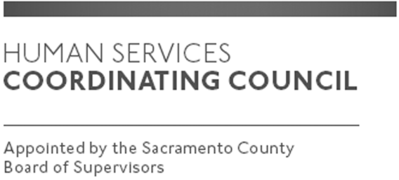

Sacramento County

Human Services Coordinating Council

Executive Committee Meeting

Staffed by Cindy Marks, DHA

Meeting Agenda
April 2, 2020, Noon

Meeting Location
Dept. of Human Assistance
Skype Conference Call

Facilitator: Ernie Brown – Chair

Meeting Invitees:
- HSCC Executive Committee
- This meeting is open to the public

Topic | Presenter
Call to Order | Chair
Approval of March 5, 2020 Minutes | Chair
Main Council Agenda for April 9, 2020 | Chair
Ad Hoc Budget Discussion | All
HSCC Moving Forward | All
Member Comments | Chair
Public Comments | Public
Announcements | TBD
Adjourn | Chair

