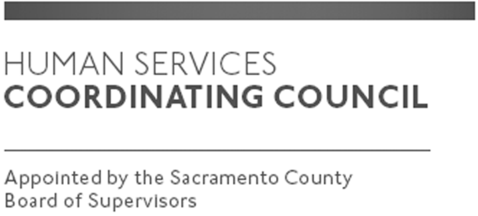

Sacramento County

Human Services Coordinating Council

Executive Committee Meeting

Staffed by Cindy Marks, DHA

Meeting Agenda
May 7, 2020, Noon

Meeting Location
Dept. of Human Assistance
Skype

Facilitator: Ernie Brown – Chair

Meeting Invitees:
- HSCC Executive Committee
- This meeting is open to the public

Topic | Presenter
Call to Order | Chair
Approval of April 2, 2020 Minutes | Chair
Main Council Agenda for May 14, 2020 | Chair
Schedule for 2020 and HSCC Heroes Event | All
COVID-19 Discussion | All
Member Comments | Chair
Public Comments | Public
Announcements | TBD
Adjourn | Chair

