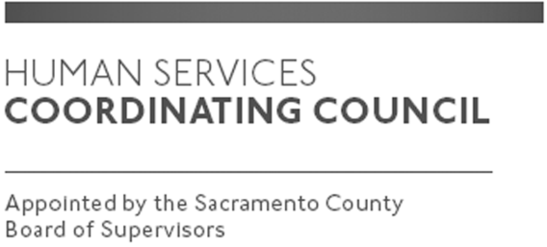

Sacramento County

Human Services Coordinating Council

Staffed by Cindy Marks, DHA

Meeting Agenda
December 12, 2019, Noon

Meeting Location
Dept. of Human Assistance
2700 Fulton Ave l Map
Sacramento, CA 95821
Conference Room 58

Facilitator: Ernie Brown – Chair

Meeting Invitees:
- HSCC Committee
- This meeting is open to the public
Topic | Presenter
Call to Order/ Potluck | Chair
Approval of November 14, 2019 Minutes | Chair
Focus of MABs Moving Forward | Chair
Melissa Jacobs-Mental Health Presentation | Mental Health
Presentation of Recommended Slate of Officers for 2019 | Secretary
Retreat January 2020–General Information and Topic Ideas | Chair
Suggestions for 2020 Speakers (January-Don Nottoli; February-Planning Commission; March- Julie Galello) | Chair
Member Comments | Chair
Public Comments | Public
Announcements | TBD
Adjourn | Chair

