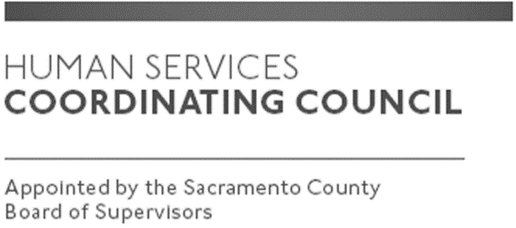

Sacramento County

Human Services Coordinating Council

Staffed by Cindy Marks, DHA

Meeting Agenda
October 10, 2019, Noon

Meeting Location
Dept. of Human Assistance
2700 Fulton Ave l Map
Sacramento, CA 95821
Conference Room 58

Facilitator: Ernie Brown – Chair

Meeting Invitees:
- HSCC Committee
- This meeting is open to the public
Topic | Presenter
Call to Order-Welcome New Members | Chair
Approval of September 12, 2019 Minutes | Chair
HSCC Heroes of Human Services Event 11.5.19 | Chair
James Boyle with Regional Transit -Presentation | Chair
Focus of MABs moving forward | Chair
Member Comments | Chair
Public Comments | Public
Announcements | TBD
Adjourn | Chair

