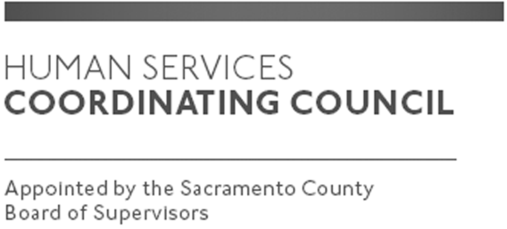

Sacramento County

Human Services Coordinating Council

Executive Committee Meeting

Staffed by Cindy Marks, DHA

Meeting Agenda
May 9, 2019, Noon

Meeting Location
Dept. of Human Assistance
2700 Fulton Ave l Map
Sacramento, CA 95821
Conference Room 58

Facilitator: Ernie Brown – Chair

Meeting Invitees:
- HSCC Executive Committee
- This meeting is open to the public

Topic | Presenter
Call to Order-Welcome New Members | Chair
Approval of February 7, 2019 and March 14, 2019 Minutes | Chair
Paul Tanner and Melinda Avey with Alcohol and Drug-Presentation | Chair
Neighborhood Association Meetings | Chair
Focus of MABs moving forward | Chair
Member Comments | Chair
Public Comments | Public
Announcements | TBD
Adjourn | Chair

