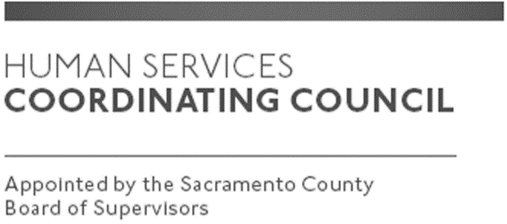

Sacramento County

Human Services Coordinating Council

Executive Committee Meeting

Staffed by Cindy Marks, DHA

Meeting Agenda
September 12, 2019, Noon

Meeting Location
Dept. of Human Assistance
2700 Fulton Ave l Map
Sacramento, CA 95821
Conference Room 58

Facilitator: Ernie Brown – Chair

Meeting Invitees:
- HSCC Executive Committee
- This meeting is open to the public

Topic | Presenter
Call to Order-Welcome New Members | Chair
Approval of August 8, 2019 Minutes | Chair
Michelle Callejas with DCFAS -Presentation | Chair
Focus of MABs moving forward | Chair
Member Comments | Chair
Public Comments | Public
Announcements | TBD
Adjourn | Chair

