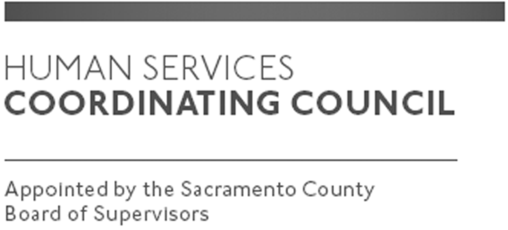

Sacramento County

Human Services Coordinating Council

Executive Committee Meeting

Staffed by Cindy Marks, DHA

Meeting Agenda
November 7, 2019, Noon

Meeting Location
Dept. of Human Assistance
2700 Fulton Ave l Map
Sacramento, CA 95821
Conference Room 58

Facilitator: Ernie Brown – Chair

Meeting Invitees:
- HSCC Executive Committee
- This meeting is open to the public

Topic | Presenter
Call to Order | Chair
Approval of October 3, 2019 Minutes | Chair
HSCC Heroes Event-November 5, 2019 | Chair
Main Council Agenda for November 14, 2019 | Chair
Member Comments | Chair
Public Comments | Public
Announcements | TBD
Adjourn | Chair

